BUSINESS INSIGHTS
1. KPI Cards
Total Customers: 7,032
Insight:
- The company currently serves 7,032 customers, which forms the basis for the churn analysis.

Active Customers: 5,163
Insight:
- Approximately 73.4% of customers are still active, indicating a healthy retained customer base.

Churn Customers: 1,869
Insight:
- A total of 1,869 customers have churned, representing a significant customer loss that requires retention strategies.

Churn Rate: 26.58%
Insight:
- More than 1 in every 4 customers has churned, which is relatively high for a telecom company and suggests improvements are needed in customer retention.

Total Revenue: 16.06M
Insight:
- The company has generated 16.06 million in revenue from the current customer base.

Average Monthly Charges: 64.80
Insight:
- Customers pay an average monthly charge of 64.80, indicating a moderate pricing level.

Average Revenue per Customer: 2.28K
Insight:
- On average, each customer contributes approximately 2.28K in lifetime revenue.

Average Tenure: 32.4 Months
Insight:
- Customers remain with the company for an average of 32 months, suggesting there is room to improve long-term customer loyalty.

2. Customers by Contract
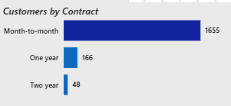
Insight
- Month-to-month contracts dominate (1,655 churned customers).
- Customers with one-year and two-year contracts show much lower churn.
- This suggests that longer contract commitments improve customer retention.
Business Recommendation
Encourage month-to-month customers to upgrade to annual contracts through discounts or loyalty incentives.

3. Customers by Internet Service
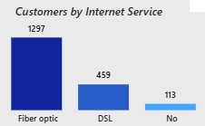
Insight
- Fiber Optic customers have the highest churn (1,297).
- DSL customers churn considerably less.
- Customers without internet service have minimal churn.
Business Recommendation
Investigate whether Fiber Optic customers are experiencing higher prices, service quality issues, or unmet expectations.

4. Average Monthly Charges vs Tenure
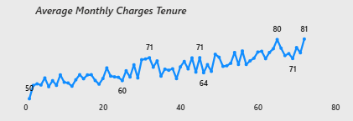
Insight
- Monthly charges generally increase as customer tenure increases.
- Long-term customers appear willing to pay higher monthly charges.
Business Recommendation
Offer premium plans and value-added services to loyal customers while keeping pricing competitive for new customers.

5. Customers by Payment Method
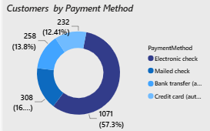
Insight
- One payment method accounts for 57.3% of churned customers.
- Other payment methods contribute significantly less.
Business Recommendation
Analyze whether this payment method is associated with manual payments, failed transactions, or customer inconvenience, and encourage customers to switch to automatic payment options.

6. Customers by Tenure Band
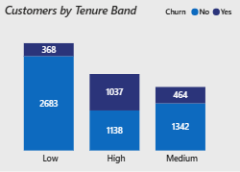
Insight
- High-risk (0–12 months): 1,037 churned customers
- Medium-risk (13–35 months): 464 churned customers
- Low-risk (36–72 months): 368 churned customers
This indicates:
- New customers are much more likely to churn.
- Customer loyalty improves significantly after the first year.
Business Recommendation
Focus retention efforts during the first 12 months through onboarding, welcome offers, proactive support, and regular engagement.

7. Top 10 Customers by Revenue
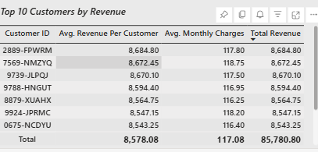
Insight
- The highest-value customers each contribute approximately 8.5K–8.7K in revenue.
- Losing even a few of these customers could significantly impact total revenue.
Business Recommendation
Create a VIP retention program for high-value customers with personalized offers, priority support, or exclusive benefits.

